Tele-Order System for Supermarket (TOSS)
Naif Mohammed Al-Oasimi, Mohammed Seter Al-Solmi, M.Rizwan Jameel Quereshi, Mutasem Jarrah, Fazal Qudus Khan
Department of Information Technology, Faculty of Computing and Information Technology, King Abdulaziz University, Jeddah, Saudi Arabia
E-mails: nayef-511@hotmail.com, moooode89@hotmail.com, anriz@hotmail.com, mutasem.jarrah@yahoo.com, fazalqudus@hotmail.com,

Abstract
In these days, the spread of commerce centers are built on huge areas that including a supermarket. It has become popular style around the world. So the common problem, when any customer wants to do shopping from supermarket or mall, is wastage of time to reach to the supermarket and do shopping at different sections of supermarket. Another problem is the permanent crowds in supermarket's queues taking account that is not organized.
To address the above problem, some supermarkets identified cashiers to serve orders for example that have less than 10 items only. This idea helped but not as expected. Other solution, they (supermarkets) allocate some cashier to serve on kind of category and separate it as a section such as newspaper, vegetables and fruit section. This idea helped a lot but caused other problems like suffocation around the exit door.
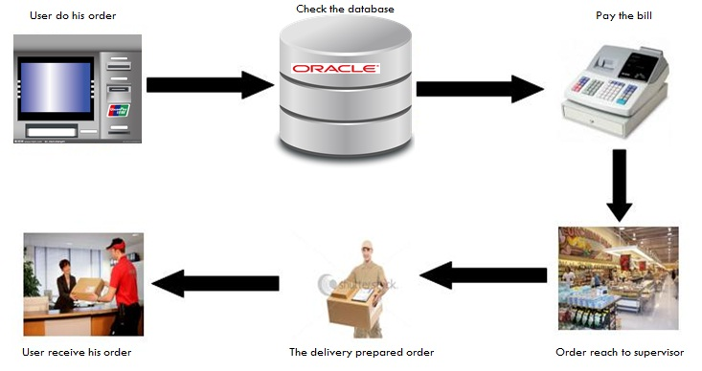
Our project is aimed to build an application that will help to reduce crowding around cashiers. Same application will also help to save time when you want to do shopping from more than one store beside the supermarket. This application will give the ability to buy from supermarket without going inside it and save time to collect his order (same as take away system).
We will determine an area in mall on the other side of supermarket that will have a terminal machine and a cashier .The terminal machine will contain all items and each item under its suitable category. The customer can choose any item of any quantity to add it to his order list. The system will print a bill containing order to make sure about it. After that, the customer will pay his bill from nearest by cashier .The order will reach to the supermarket. A supervisor will control these orders and distribute to deliver. At this time, the customer can shop from some other store until his order will reach to same cashier that he has paid.
A terminal machine like (ATM) system is required to implement this system. C# programming language and SQL server will based as implementation tools. A small network will connect the system with supermarket's supervisor.

